GENERAL COUNSELLING DOCUMENTATION

This web application is used to digitalise the general counselling process of our college. This application has three modules namely **Admin, Staff and Student.**

1. **HOME PAGE / STUDENT FORM**

This page displays a form, that should be filled by all the students before entering into the counselling.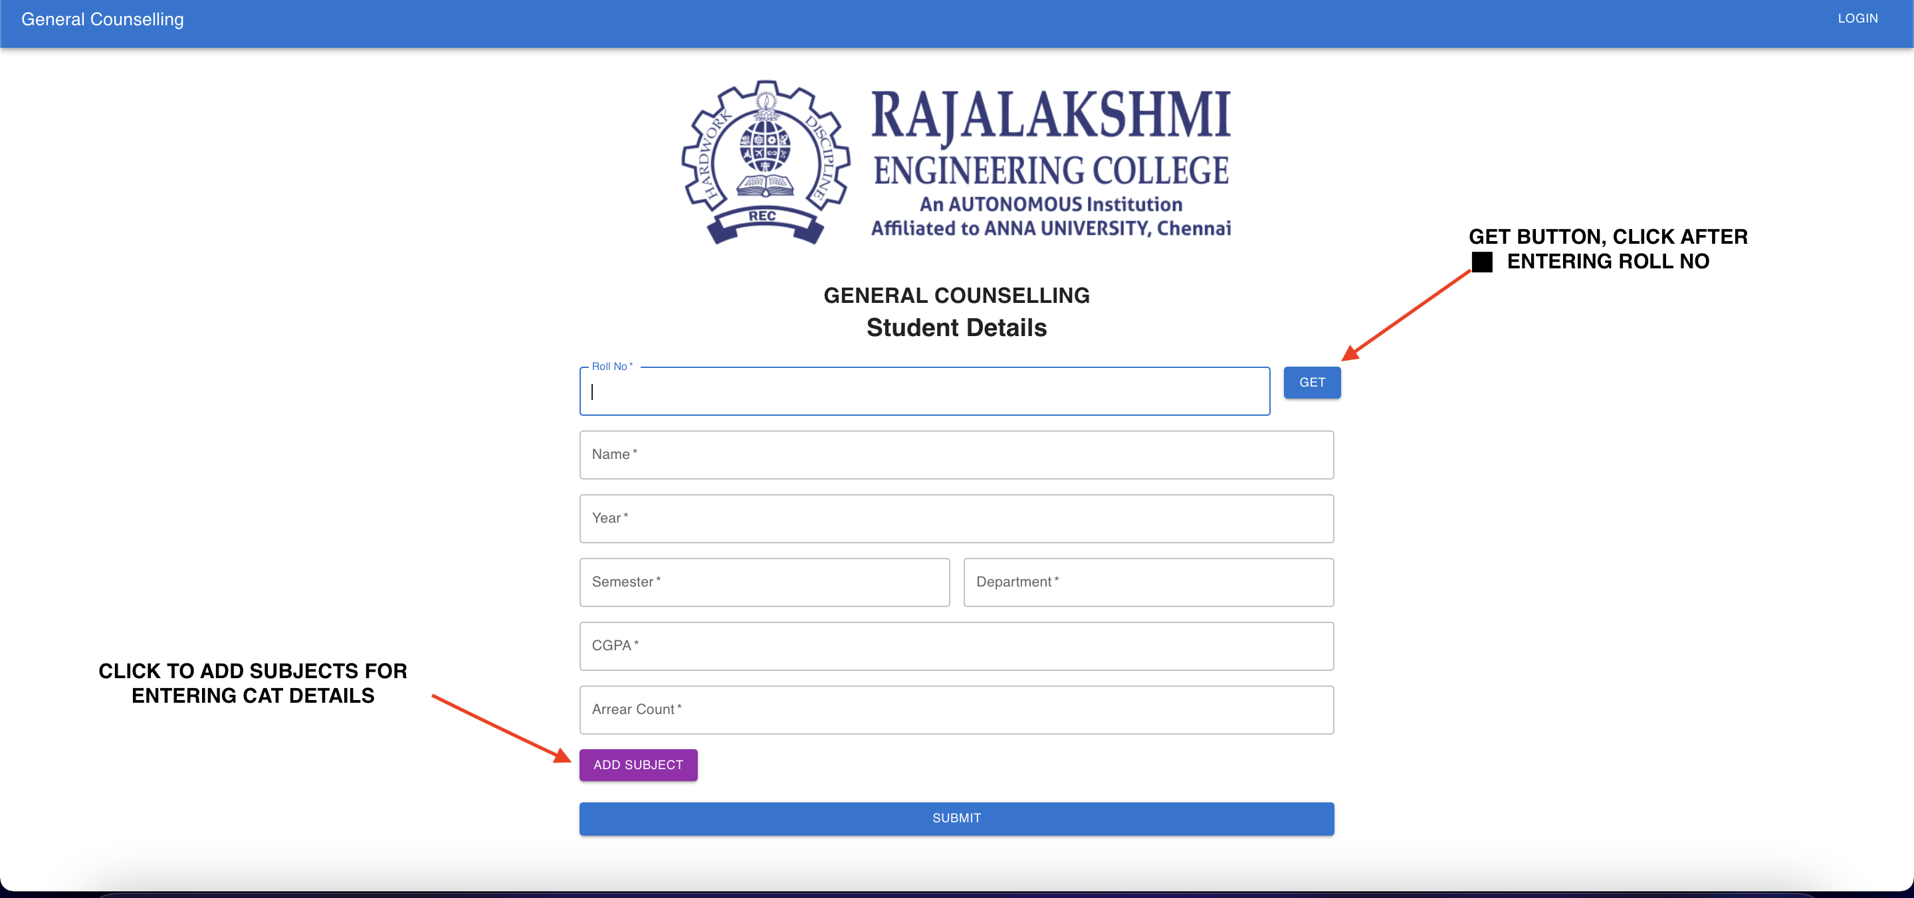

**SCENARIO 1: FORM FILLING**

**STEPS:**

1. Go to the form.

2. **Fill all general details** such as roll no, name, year, department, semester, arrear count (**Note**: All fields are mandatory)

3. Click **Add subject** **button** to enter the details of that particular semester’s subjects.

**Example**: Let’s say if that semester has 5 subjects, then Add subject button will be clicked 5 times.

4. Fill **subject code, subject name, cat mark and attendance** percentage of that subject. (**Note:** All fields are mandatory)

5. Similarly to remove a subject **(-) button** can be used.

6. Click submit.

7. Ale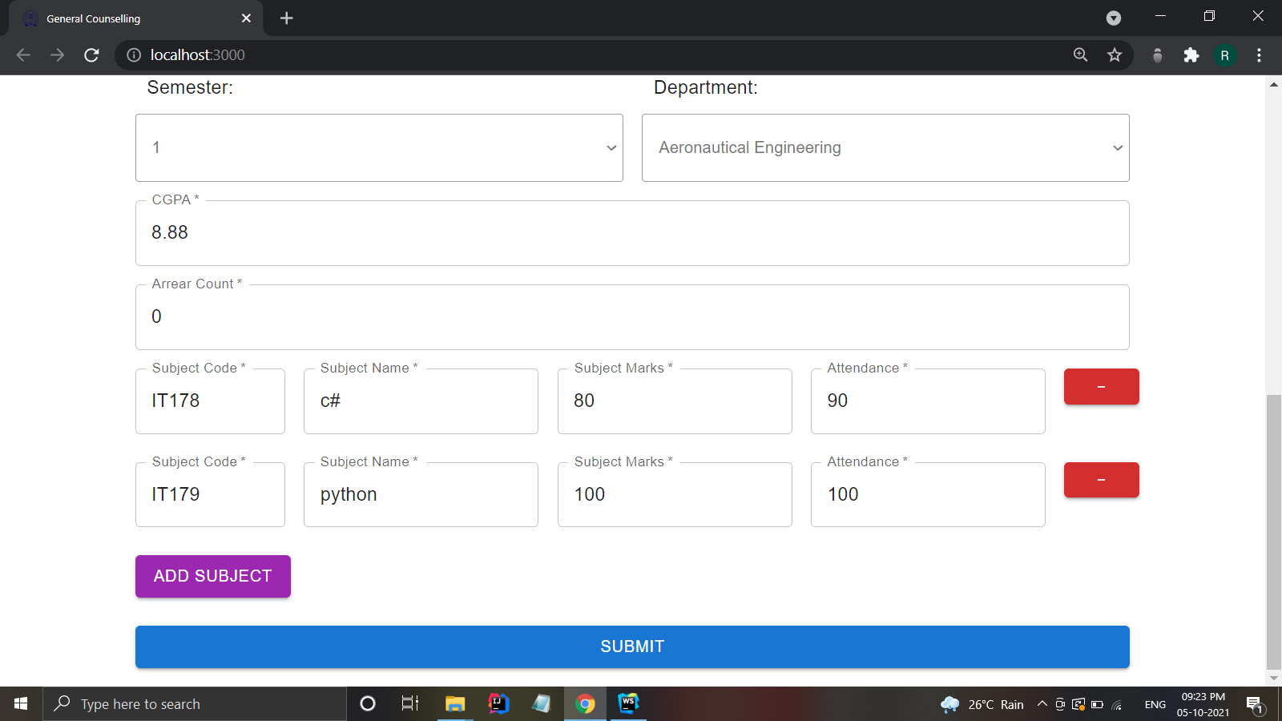rt box will be showed on **successful entry.**

**SCENARIO 2: FORM EDITING**

In case, if the students has filled wrong details or want to change a thing or two in the form that have been already submitted or just want to view their details.

**STEPS:**

1. Go to the form

2. Enter your **ROLL NO.**

3. Click the **GET** button.

4. Wait for the existing data to be displayed in the **same form**. **(Note:** The GET button only works, if the student has already filled the form and entered correct ROLL NO. to retrieve the data **)**

5. Make your changes if any.

6. Click submit.

7. Alert box will be showed on **successful entry.**

1. **LOGIN PAGE**

This page is common for both admin and staffs.

1. **Admins** should use the the **form** to enter their username and password to sign in

2. Staffs should use the **google sign in** button. (**Note:** Only email id’s that belong to Rajalakshmi organisation is allowed)

STEPS:

**For admin:**

1. Enter the given **username**

2. Enter the **password.**

3. Click login, you will be **redirected to admin home page**.

**For staff:**

1. Click on google sign in. **(Note:** Kindly enable cookies for smooth user experience**)**

2. New **window pop up** will be shown.

3. **Select the account** to log in

4. Enter the password and click next.

5. Shortly you will be **redirected back to the the counselling website.**

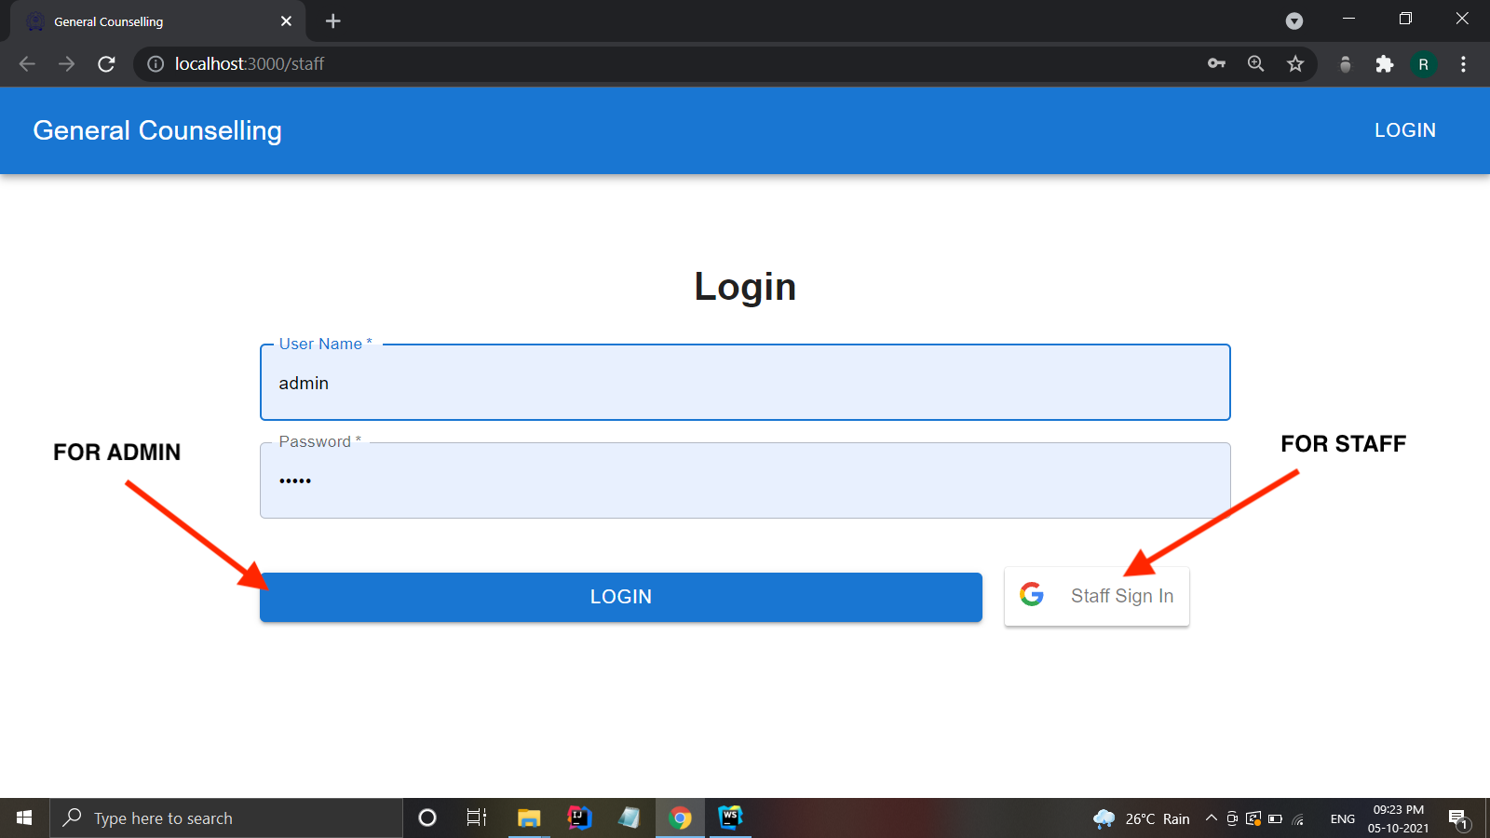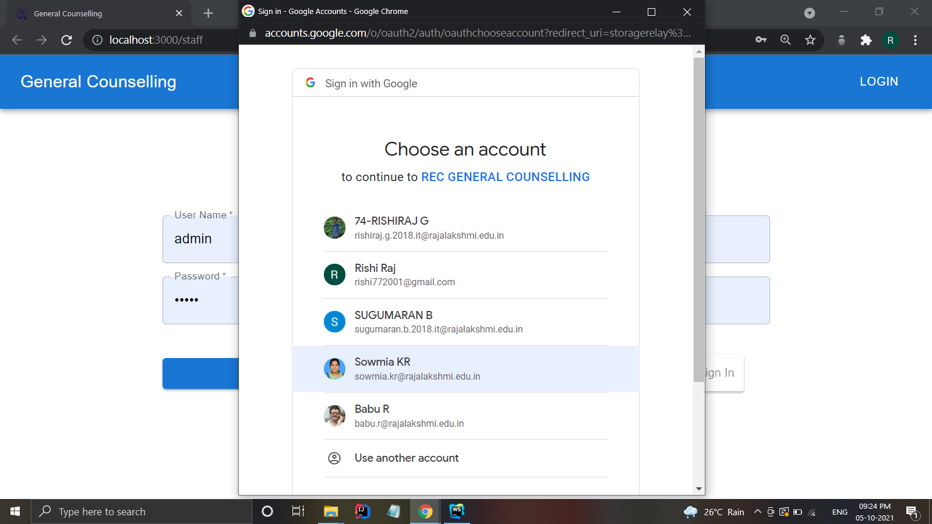

1. **STAFF PAGE**

This page is only visible to staffs when they are signed in using their given college email id. Once the staff is signed in, student form is displayed.

**SCENARIO 1: GETTING STUDENT DETAILS**

All students details is accessible to staffs. To get any student’s details during the counselling session the following has to be done:

**STEPS:**

1. Go to the form

2. Enter the students **ROLL NO.**

3. Click the **GET** button.

4. Wait for the existing data to be displayed in the **same form**. **(Note:** The GET button only works, **if the student has already filled the form** and have entered correct ROLL NO. to retrieve the data **)**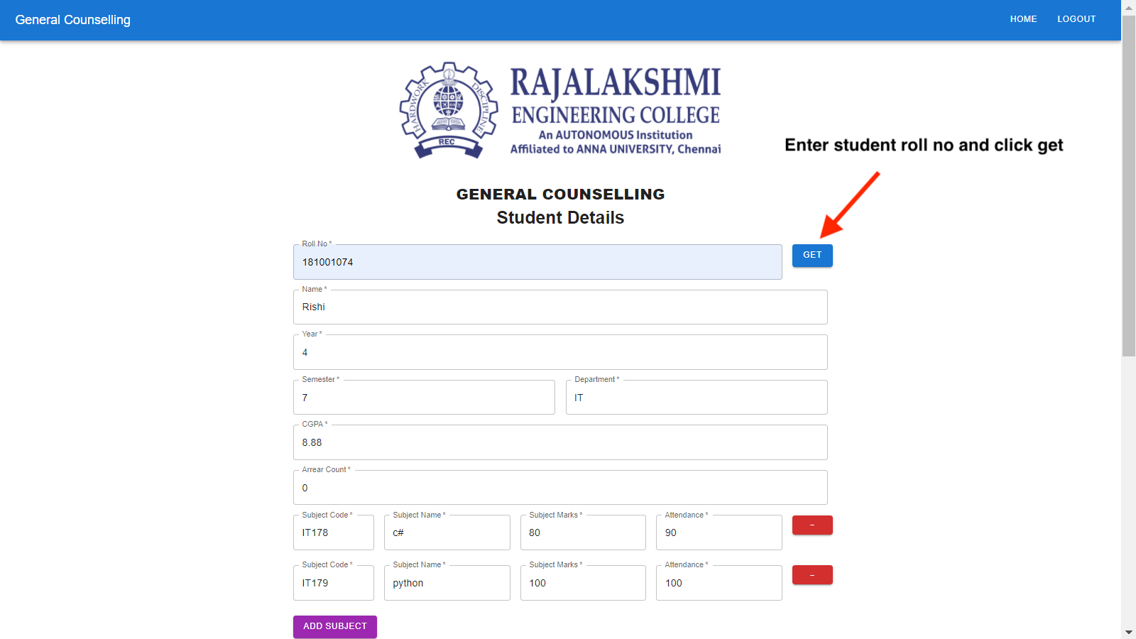

**SCENARIO 2: FILLING & EDITING COUNSELLING DETAILS / GRIEVANCES FORM**

This form is automatically displayed once the staff enters a student’s roll no and click GET.

**STEPS:**

A set of **DEFAULT ISSUE CATEGORIES** is shown with **“YES”** or **“NO”** options.

1. Click **“YES”**, which will display a **TEXT-BOX** to add any comments for the particular issue.

2. Repeat the same for all issues.

**Example:** Let’s say the student has some complaints regarding transport, Go to transport issue -> Click “YES” -> Enter the issue.

3. In case, if it's not possible to categorise the issue said by the student under the default issue categories. Kindly make use of the **“GENERAL ISSUE”** section.

4. Leave the buttons as **“NO”** in case of no issues.

5. Staffs can also add **“REMARKS”** if any under the remarks section.

6. Click submit, once the counselling session ends.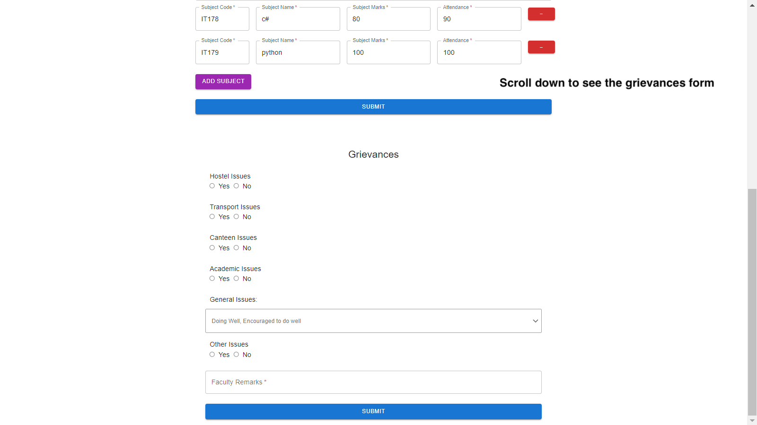

**NOTE: The same step is repeated for editing or to make corrections in the grievances form. In case the staff wants to edit the form that they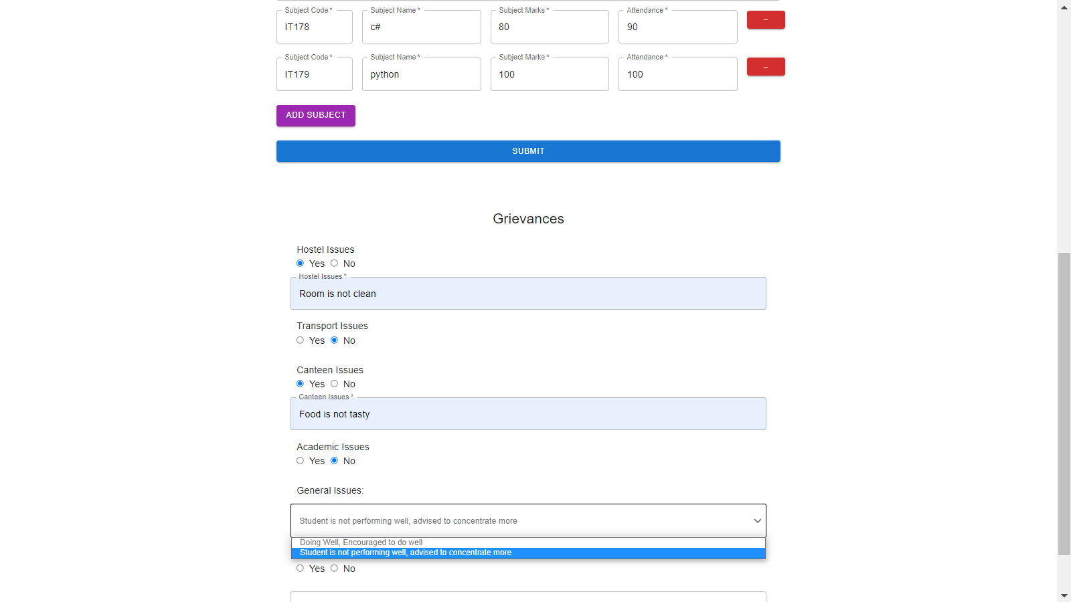 submitted:**Enter the student’s roll no. -> Click GET -> students details and grievance details will be displayed if exists -> Make changes if any -> Click submit.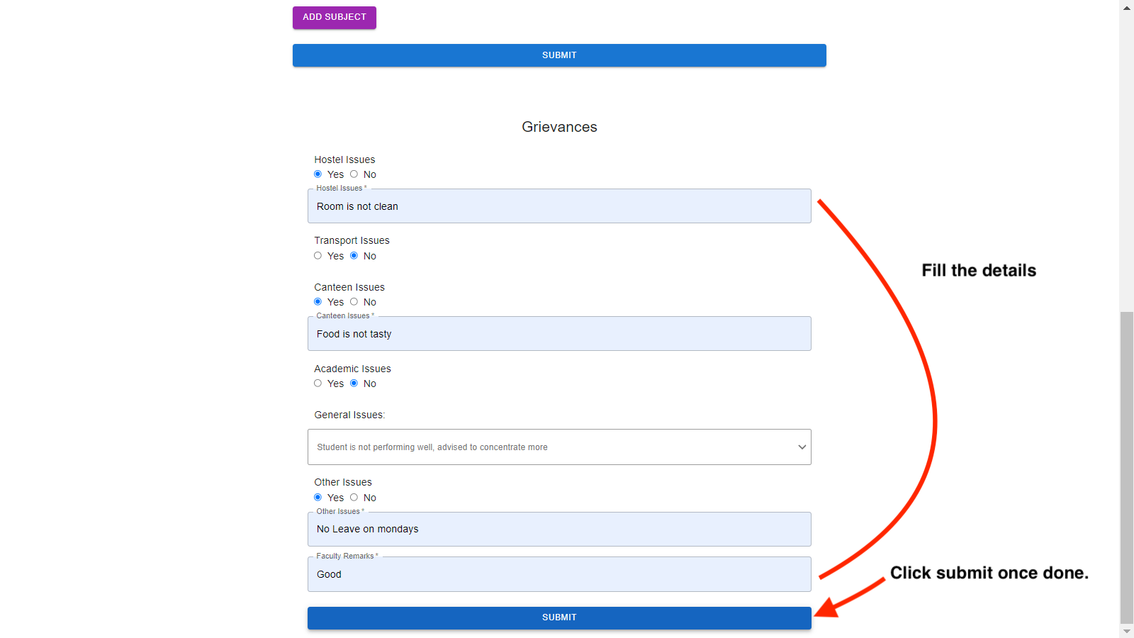

1. **ADMIN’s DASHBOARD**

This page is displayed once the admin is logged in using the **LOGIN PAGE.**

**By default:** The admin will be showed all the general counselling details in a table.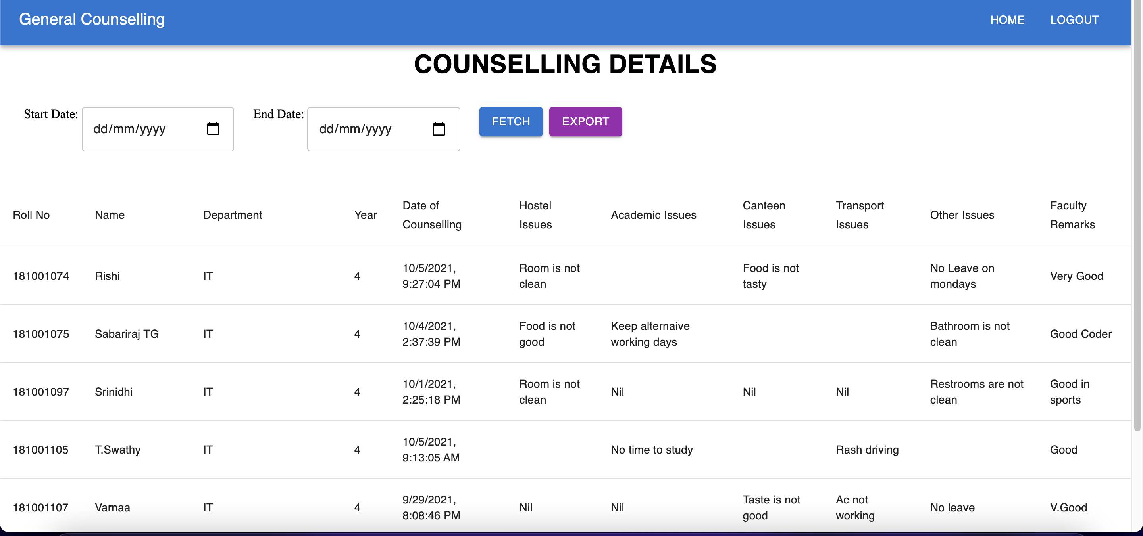

**ACTIONS THAT CAN BE PERFORMED:**

1. **Filter By DATE**

**STEPS:**

1. Use the **START DATE** to select the “Starting date” of the counselling details that one likes to view.

2. Use the **END DATE** box to select the “Ending date” of the counselling details that one likes to view.

3. Click **FETCH**

4. Counselling details will be **displayed in the table**, if present for the selected dates.

**NOTE:** Both starting date and ending date is **INCLUSIVE.**

**Example:**

1. To view the counselling details for the date of “28.10.2021” the filters would look something like this:

**1. Starting Date = 28.10.2021**

**2. Ending Date = 28.10.2021**

2. To view all the counselling details that happened between 25.10.2021 - 28.10.2021 the filters would look something like this:

**1. Starting Date = 25.10.2021**

**2. Ending Date = 28.10.2021**

This will fetch all the counselling details that happened from the date of 25/10/2021 to 28/10/2021 **BOTH INCLUSIVE.**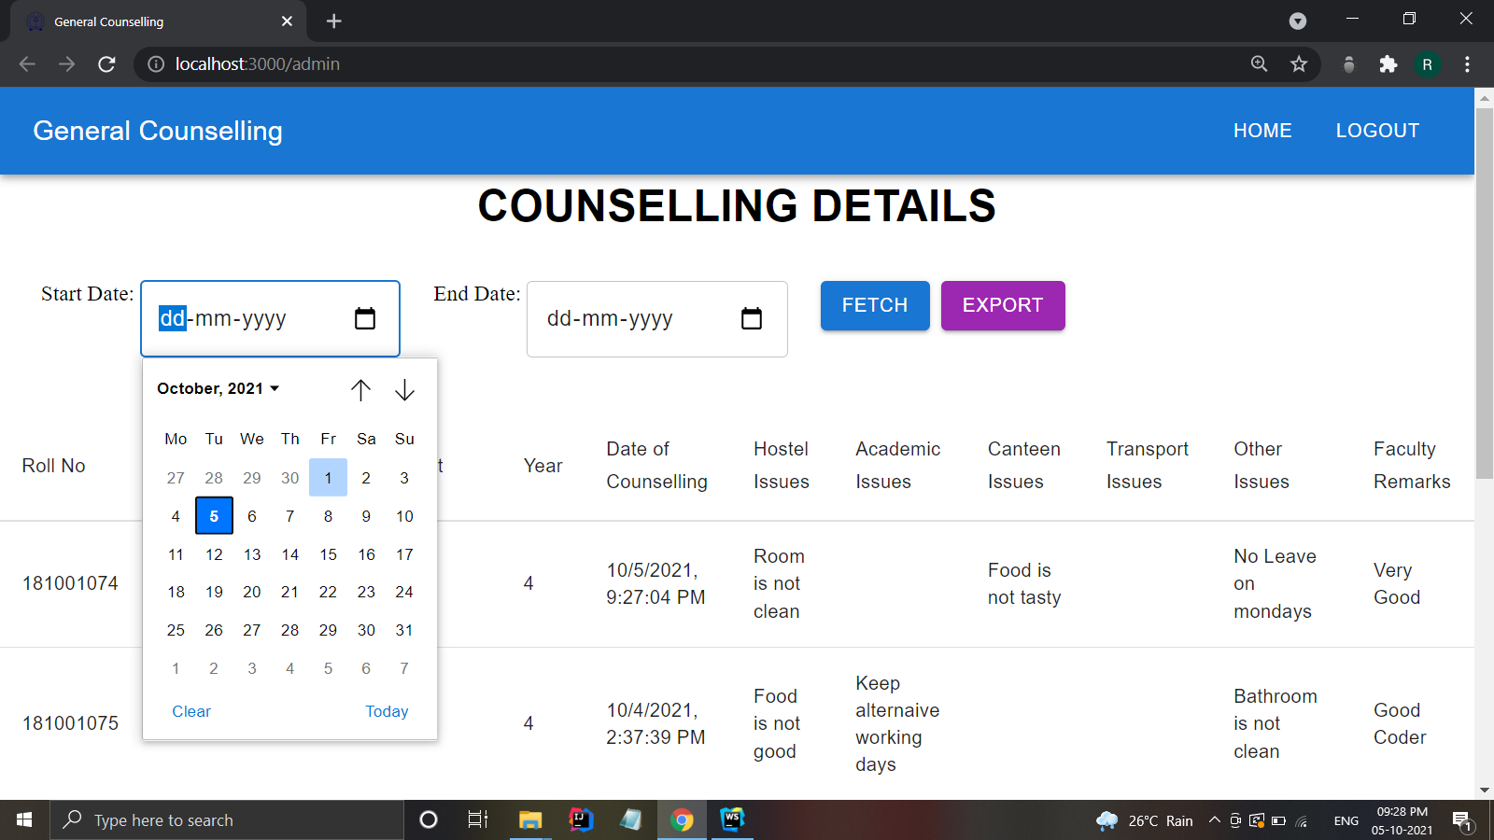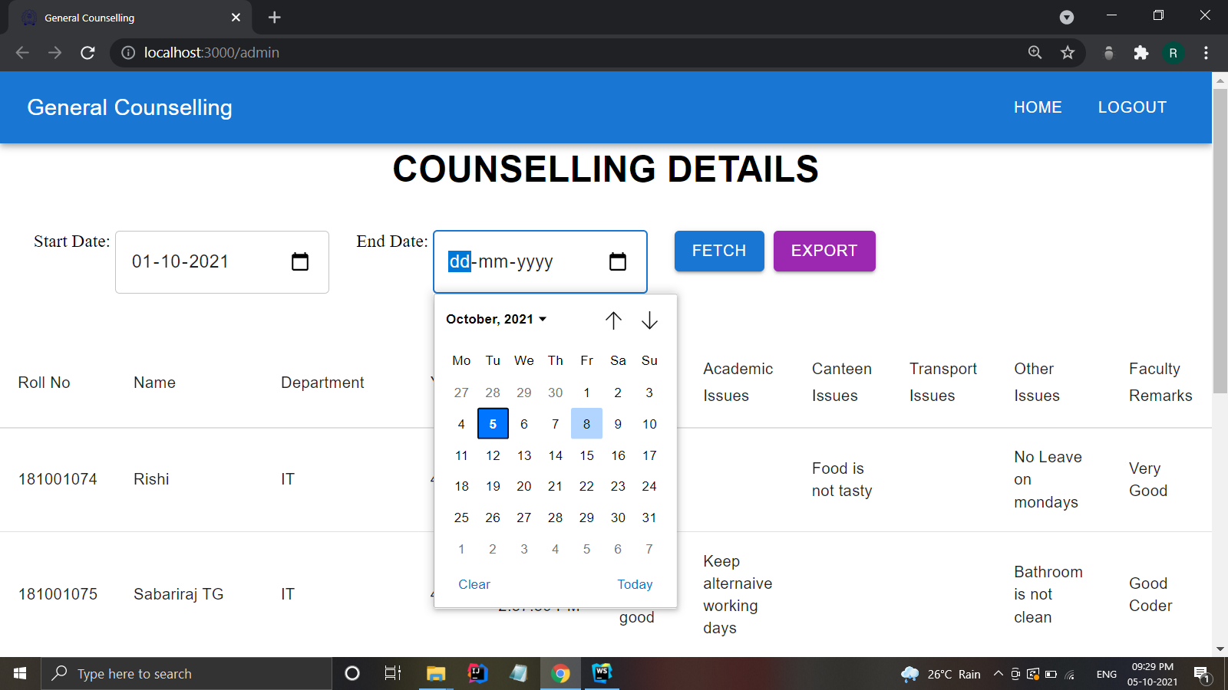

1. **Export to EXCEL**

All counselling details or any custom custom counselling details retrieved by using the “custom dates” can be used to export in the form of excel by clicking the **“EXPORT”** button.